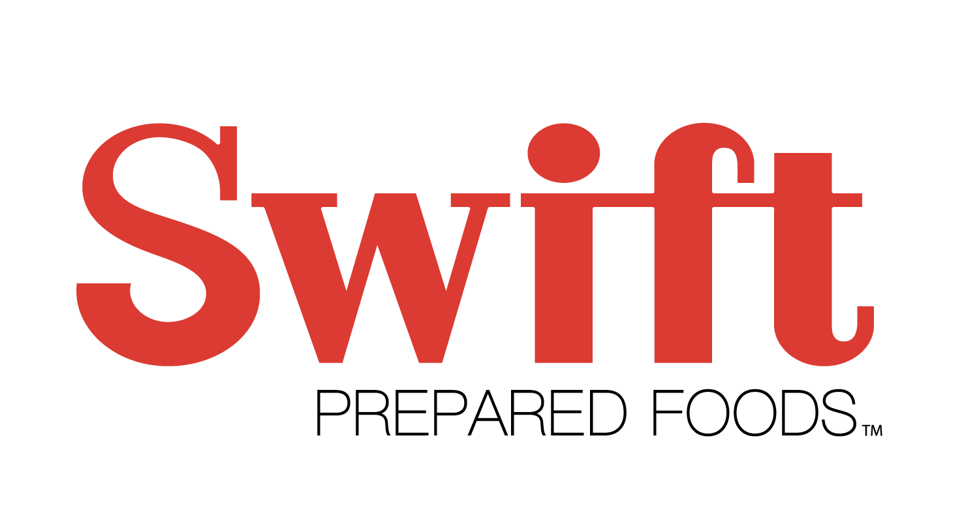
Are you ready to start a career with us?

Who are we?
We are Swift Prepared Foods, a new bacon processing facility in Moberly! We have jobs such as front line production workers, maintenance positions, quality technicians and more.
Production Job requirements:
- You must be 18 years’ old
- The job entails repetitive line work
- Possible lifting
- Possible work with box knives
- Work in cold damp conditions
- Work with unpleasant odors
- Work in areas with potential extreme heat
- You must be able to meet the expectations of attendance and our work rules.

***Starting Pay $16.00/hour***

Hours of Operation: We have 2 shifts. Our employees will work 4 days and then have 4 days off.
- 1st shift – 4am to 4pm
- 2nd shift – 4pm to 4am

